**HOTEL MANAGEMENT SYSTEM**

*A MINOR PROJECT-1(CS508)*

*Submitted in partial fulfillment of the requirement for the*

*Award of Degree of*

*Bachelor of Technology in Computer Science & Engineering*

**Submitted to**



**RAJIV GANDHI PROUDYOGIKI VISHWAVIDHYALAYA,**

**BHOPAL(M.P.)**

**Submitted by**

Name of Student- Harshraj Singh Thakur[0111ME211041]

**Under the Guidance of**

Mr./Dr./Prof. Guides Name

(Designation,CSE Department)



**DEPARTMENT OF COMPUTER SCIENCE & ENGINEERING**

**TECHNOCRATS INSTITUTE OF TECHNOLOGY,BHOPAL**

**SESSION: July-Dec 2023**

**TECHNOCRATS INSTITUTE OF TECHNOLOGY, BHOPAL**

**DEPARTMENT OF COMPUTER SCIENCE & ENGINEERING**



***CERTIFICATE***

This is to certify that the work embodies in this Minor Project-I (CS508) work entitled “HOTEL MANAGEMENT SYSTEM” being submitted by HARSHRAJ SINGH THAKUR(0111ME211041), in partial fulfillment of the requirement for the award of Bachelor of Technology in COMPUTER SCIENCE & ENGINEERING to Rajiv Gandhi Proudyogiki Vishwavidyalaya, Bhopal ( M.P.) during the session July-Dec 2023 is a record of bonafide piece of work, carried out by him/her/them under my supervision and guidance in the Computer Science & Engineering, Technocrats Institute of Technology, Bhopal Guided by: Prof. Guide Name (Designation) COMPUTER SCIENCE & ENGINEERING

**GUIDED BY: APPROVED BY:**

**PROF. Guide Name Dr. Manoj Tyagi**

**(Designation) Head of the Department**

**COMPUTER SCIENCE & ENGINEERING COMPUTER SCIENCE & ENGINEERING**

**TECHNOCRATS INSTITUTE OF TECHNOLOGY, BHOPAL**

**DEPARTMENT OF COMPUTER SCIENCE & ENGINEERING**



***DECLARATION***

We/I, HARSHRAJ SINGH THAKUR Student Of Bachelor Of Technology in COMPUTER SCIENCE & ENGINEERING, session July-Dec 2023 Technocrats Institute of Technology ,Bhopal M.P., hereby declare that the work presented in this project Report entitled “HOTEL MANAGEMENT SYSTEM” is the outcome of our own work, is bona fide and correct to the best of our knowledge and this work has been carried out taking care of Engineering

**Name of Student – Harshraj Singh Thakur**

**Enrollment no.- 0111ME211041**

***ACKNOWLEDGEMENT***

I deem it’s my privilege to extent my profound gratitude and appreciation towards all those who have directly or indirectly involved themselves in making this project a great success. It gives me immense pleasure to express my deepest sense of gratitude and sincere thanks to my respected guide Prof. Guide name for his valuable guidance encouragement and help for this work.

I would also like to express my sincere thanks to Dr. Shashi Kumar Jain, Director Technocrats Institute of Technology, Bhopal for his encouragement and support.

I would also like to thank Dr. Manoj Tyagi, Head of Department Computer Science & Engineering for providing me with all the moral support and necessary help.

I am also thankful to all the staff members of the Institute for their cooperation in my work. My sincere appreciation and thanks to my family members and friends for keen interest, continued encouragement and support.

**Name of Student- Harshraj Singh Thakur**

**Enrollment No.- 0111ME211041**

***ABSTRACT***

The knowledge and understanding of quality standards of guests helps hotel managers improve the quality of hotel services and increase guests’ satisfaction with the hotel stay. Different aspects of a hotel offer participate in the guests’ evaluation of the hotel experience. The factors that influence guests’ satisfaction level are also named “hotel attributes”. There exist a large number of factors that influence guests’ impressions, but certainly not all of them have the same level of importance for guests. In order to be aware of the strengths and weaknesses of their businesses, hotel management has to identify which improvements in the hotel operations can bring additional value to their guests. One of the most reliable information sources for gaining customer knowledge is undoubtedly the feedback provided directly from customers. If analyzed properly, it can be exploited for the purpose of improving the hotel operations and raising profits.

The environment in which hospitality businesses operate nowadays has become radically connected to the use of the Internet. An increase in the usage of Social Media triggered extreme changes in the information channels that hotel guests use in order to make booking decisions. Hence, the hotel management should be aware that travel information websites present a valuable source of information about customer preferences. They offer service providers a possibility to have an insight into the reasons for satisfaction or disappointment of their guests.

The aim of this thesis is to examine the relationship between different hotel attributes and the guests’ overall satisfaction with the hotel stay. It tries to uncover the most influential hotel attributes for the formation of guests’ satisfaction.

***INTRODUCTION***

Welcome to **HOTEL CROWN**, where impeccable hospitality meets unparalleled comfort.

At **HOTEL CROWN**, we redefine luxury and guest satisfaction. With a passion for excellence ingrained in our ethos, we specialize in delivering a seamless experience for every guest. Nestled in **Bhopal**, our hotel stands as a beacon of refined elegance and world-class service.

Our commitment to personalized attention ensures that each stay is tailored to exceed expectations. Whether you're here for business or leisure, our dedicated team is poised to make your experience unforgettable.

From our meticulously designed rooms to our exquisite dining options and state-of-the-art facilities, every aspect of **HOTEL CROWN** reflects sophistication and attention to detail. Our dedication to sustainability means that your comfort doesn’t come at the expense of the environment.

We take pride in our rich heritage of hospitality and innovation, constantly striving to set new standards in the industry. Join us on a journey where luxury meets warmth, and every moment is curated to perfection.

Discover the epitome of hospitality at **HOTEL CROWN**. Your unforgettable stay begins here.

***LITERATURE REVIEW***

* **Customer Experience and Satisfaction:**
  + Explore studies on customer preferences, expectations, and satisfaction levels in the hospitality industry.
  + Examine strategies for enhancing guest experiences and loyalty.
  + Investigate the impact of technology on improving guest satisfaction, such as AI-driven services, mobile apps, or self-service kiosks.
* **Service Quality and Management:**
  + Review literature on service quality models (like SERVQUAL) used in the hotel industry and their application.
  + Discuss best practices in service management, including training, employee engagement, and service recovery strategies.
* **Marketing and Branding:**
  + Analyze branding strategies adopted by various hotel chains and their impact on consumer behavior.
  + Study digital marketing trends and their influence on hotel bookings and customer engagement.
  + Examine the use of social media in hotel marketing and its effectiveness
* **Sustainability in Hospitality:**
  + Investigate sustainable practices in the hotel industry, such as energy conservation, waste reduction, and community involvement.
  + Review studies on consumer perceptions and behaviors toward eco-friendly hotels.
* **Revenue Management and Pricing Strategies:**
  + Explore revenue management techniques used in hotels, including dynamic pricing, yield management, and distribution strategies.
  + Discuss the impact of online travel agencies (OTAs) and their role in pricing and distribution.
* **Technology and Innovation:**
  + Review literature on the integration of technology in hotel operations, like IoT, blockchain, or data analytics for personalized guest experiences.
  + Discuss the challenges and opportunities of adopting new technologies in the hospitality industry.
* **Human Resource Management:**
  + Examine HR practices in the hospitality sector, focusing on recruitment, training, retention, and employee satisfaction.
  + Explore the impact of employee engagement on guest satisfaction and overall hotel performance.
* **Crisis Management and Risk Mitigation:**
  + Investigate crisis management plans within the hotel industry, particularly in response to natural disasters, pandemics, or other unforeseen events.
  + Discuss risk assessment and mitigation strategies implemented by hotels.

***PROBLEM STATEMENT***

"Despite advancements in technology and service standards, the hospitality industry, particularly hotel management, faces ongoing challenges in optimizing operational efficiency, enhancing guest experiences, and maintaining sustainable practices. Issues such as manual processes leading to operational bottlenecks, inconsistent service quality, ineffective inventory management, and the need to adapt to evolving guest preferences pose significant hurdles for hotels in delivering seamless services. Balancing traditional hospitality values with the demand for tech-integrated, personalized experiences while ensuring cost-effectiveness remains a substantial challenge. Addressing these concerns is crucial to establish hotels as competitive, adaptable, and sustainable entities in an ever-evolving market."

This problem statement sets the stage for exploring various facets of hotel management, such as technological integration, guest experience enhancement, operational streamlining, and sustainability practices.

***PROJECT ANALYSIS***

A project analysis in hotel management can encompass various facets, ranging from financial feasibility to operational efficiency. Here's an outline of key areas to cover:

* **Executive Summary:**
  + Overview of the project's objectives, scope, and key findings.
* **Market Analysis:**
  + Identification of target demographics and market trends.
  + Competitor analysis to understand market positioning and strategies.
  + Analysis of demand and supply dynamics in the local/national/global context.
* **Financial Feasibility:**
  + Cost estimation: Construction, equipment, staff, marketing, etc.
  + Revenue projections: Room rates, occupancy rates, F&B sales, and other services.
  + Break-even analysis and return on investment (ROI) calculations.
  + Funding sources and financial strategies.
* **Operational Plan:**
  + Organizational structure: Departments, staffing requirements, hierarchy.
  + Operational workflow: Check-in/out procedures, housekeeping, F&B operations, etc.
  + Technology integration: Property management systems, booking platforms, etc.
  + Compliance with regulations and standards (health, safety, hospitality industry norms).
* **Marketing Strategy:**
  + Branding: Positioning, unique selling propositions (USPs).
  + Distribution channels: Online travel agencies, direct bookings, partnerships.
  + Promotional strategies: Advertising, social media, loyalty programs.
* **Risk Analysis:**
  + Identification of potential risks: Market fluctuations, regulatory changes, etc.
  + Mitigation strategies: Contingency plans, insurance coverage, risk diversification.
* **Sustainability and Environmental Impact:**
  + Sustainable practices in operations: Waste management, energy efficiency, etc.
  + Social responsibility initiatives: Community engagement, ethical sourcing, etc.
* **SWOT Analysis (Strengths, Weaknesses, Opportunities, Threats):**
  + Internal and external factors influencing the project's success.
* **Implementation Timeline:**
  + Phased plan detailing construction, hiring, marketing launch, etc.
  + Milestones and dependencies.
* **Conclusion and Recommendations:**
  + Summary of key findings and insights.
  + Recommendations for strategic decisions or adaptations.
* **Appendices:**
  + Additional data, charts, detailed financial breakdowns, etc.

Each section should be supported by thorough research, data analysis, and clear explanations. This structure can help create a comprehensive project analysis for hotel management, aiding decision-making and garnering support for the project.

***Requirement Specification***

Front -end :-

* HTML
* CSS
* JAVASCRIPT

**HTML:-**

**HTML (Hypertext Markup Language)** is a text-based approach to describing how content contained within an HTML file is structured. This markup tells a web browser how to display text, images and other forms of multimedia on a webpage. HTML is a formal recommendation by the World Wide Web Consortium (W3C) and is generally adhered to by all major web browsers, including both desktop and mobile web browsers. HTML5 is the latest version of the specification. Using HTML, a text file is further marked up with additional text describing how the document should be displayed. To keep the markup separate from the actual content of the HTML file, there is a special, distinguishing HTML syntax that is used. These special components are known as HTML tags. The tags can contain name-value pairs known as attributes, and a piece of content that is enclosed within a tag is referred to as an HTML element. HTML elements always have opening tags, content in the middle and closing tags. Attributes can provide additional information about the element and are included in the opening tag. HTML tags dictate the overall structure of a page and how the elements within them will be displayed in the browser. Commonly used HTML tags include:

* <h1> which describes a top-level heading.
* <h2> which describes a second-level heading.
* <p>which describes a paragraph.
* <table> which desribes tabular data.
* <ol> which describes an ordered list of information.
* <ul>which describes an unordered list of information.

**CSS:-**

**Cascading Style Sheets (CSS)** is a style sheet language used for describing the presentation of a document written in a markup language such as HTML or XML (including XML dialects such as SVG, MathML or XHTML). CSS is a cornerstone technology of the World Wide Web, alongside HTML and JavaScript. CSS is designed to enable the separation of content and presentation, including layout, colors, and fonts. [3] This separation can improve content accessibility; provide more flexibility and control in the specification of presentation characteristics; enable multiple web pages to share formatting by specifying the relevant CSS in a separate .css file, which reduces complexity and repetition in the structural content; and enable the .css file to be cached to improve the page load speed between the pages that share the file and its formatting. Separation of formatting and content also makes it feasible to present the same markup page in different styles for different rendering methods, such as on-screen, in print, by voice (via speech-based browser or screen reader), and on Braille-based tactile devices. CSS also has rules for alternate formatting if the content is accessed on a mobile device. The name cascading comes from the specified priority scheme to determine which style rule applies if more than one rule matches a particular element. This cascading priority scheme is predictable. The CSS specifications are maintained by the World Wide Web Consortium (W3C). Internet media type (MIME type) text/css is registered for use with CSS by RFC 2318 (March 1998). W3C operates a free CSS validation service for CSS documents. (x)

**JAVASCRIPT:-**

**JavaScript** is a dynamic computer programming language. It is lightweight and most commonly used as a part of web pages, whose implementations allow client-side script to interact with the user and make dynamic pages. It is an interpreted programming language with object-oriented capabilities. JavaScript was first known as LiveScript, but Netscape changed its name to JavaScript, possibly because of the excitement being generated by Java. JavaScript made its first appearance in Netscape 2.0 in 1995 with the name LiveScript. The general-purpose core of the language has been embedded in Netscape, Internet Explorer, and other web browsers. The ECMA-262 Specification defined a standard version of the core JavaScript language.

* JavaScript is a lightweight, interpreted programming language.
* Designed for creating network-centric applications.
* Complementary to and integrated with Java.
* Complementary to and integrated with HTML.
* Open and cross-platform

JavaScript can be implemented using JavaScript statements that are placed within the HTML tags in a web page.

You can place the <script> tags, containing your JavaScript, anywhere within your web page, but it is normally recommended that you should keep it within the <head> tag.

The <script> tag alerts the browser program to start interpreting all the text between these tags as a script.

***PROJECT DESIGN***

**Introduction to UML:**

The Unified Modeling Language (UML) is a general-purpose modeling language that is intended to provide a standard way to visualize the design of a system.

UML provides a standard notation for many types of diagrams which can be roughly divided into 3 main groups: behavior diagrams, interaction diagrams, and structure diagrams.

The creation of UML was originally motivated by the desire to standardize the disparate notational systems and approaches to software design. It was developed at Rational Software in 1994–1995, with further development led by them through 1996.

In 1997, UML was adopted as a standard by the Object Management Group (OMG), and has been managed by this organization ever since. In 2005, UML was also published by the International Organization for Standardization (ISO) as an approved ISO standard. Since then the standard has been periodically revised to cover the latest revision of UML.

In software engineering, most practitioners do not use UML, but instead produce informal hand drawn diagrams; these diagrams, however, often include elements from UML.

A picture is worth a thousand words, this idiom absolutely fits describing UML. Object-oriented concepts were introduced much earlier than UML. At that point of time, there were no standard methodologies to organize and consolidate the object-oriented development. It was then that UML came into picture.

There are a number of goals for developing UML but the most important is to define some general purpose modeling language, which all modelers can use and it also needs to be made simple to understand and use.

UML diagrams are not only made for developers but also for business users, common people, and anybody interested to understand the system. The system can be a software or non-software system.

Thus it must be clear that UML is not a development method rather it accompanies with processes to make it a successful system.

In conclusion, the goal of UML can be defined as a simple modeling mechanism to model all possible practical systems in today’s complex environment.

**UML Diagram:**

There are two main categories; structure diagrams and behavioral diagrams.

**1.Structural Diagrams** :-

Structure diagrams show the things in the modeled system. In a more technical term, they show different objects in a system.

**1. Class Diagram**

Class diagrams are the main building block of any object-oriented solution. It shows the classes in a system, attributes, and operations of each class and the relationship between each class.

**2.Component Diagram**

A component diagram displays the structural relationship of components of a software system. These are mostly used when working with complex systems with many components. Components communicate with each other using interfaces. The interfaces are linked using connectors.

**3.Deployment Diagram**

A deployment diagram shows the hardware of your system and the software in that hardware. Deployment diagrams are useful when your software solution is deployed across multiple machines with each having a unique configuration.

**4.Object Diagram**

Object Diagrams, sometimes referred to as Instance diagrams are very similar to class diagrams. Like class diagrams, they also show the relationship between objects but they use real-world examples.

**5.Package Diagram**

As the name suggests, a package diagram shows the dependencies between different packages in a system.

**2.Behavioral Diagrams**

**1.Use Case Diagram**

As the most known diagram type of the behavioral UML types, Use case diagrams give a graphic overview of the actors involved in a system, different functions needed by those actors and how these different functions interact.

**2.Activity Diagram**

Activity diagrams represent workflows in a graphical way. They can be used to describe the business workflow or the operational workflow of any component in a system. Sometimes activity diagrams are used as an alternative to State machine diagrams.

**3.State Machine Diagram**

State machine diagrams are similar to activity diagrams, although notations and usage change a bit. They are sometimes known as state diagrams or state chart diagrams as well. These are very useful to describe the behavior of objects that act differently according to the state they are in at the moment.

**4.Sequence Diagram**

Sequence diagrams in UML show how objects interact with each other and the order those interactions occur. It’s important to note that they show the interactions for a particular scenario. The processes are represented vertically and interactions are shown as arrows.

**5.Communication Diagram**

In UML 1 they were called collaboration diagrams. Communication diagrams are similar to sequence diagrams, but the focus is on messages passed between objects.

***PROJECT DIAGRAM***

**1.USE CASE DIAGRAM**

In this diagram:

* **Actors:**
  + **Guest:** Represents individuals staying at the hotel.
  + **Receptionist:** Handles check-ins, check-outs, and manages reservations.
  + **Manager:** Monitors and oversees the hotel operations.
  + **Housekeeping:** Manages room cleanliness and maintenance.
* **Use Cases:**
  + **Make Reservation:** Allows guests to book rooms.
  + **Check-In:** Enables guests to register into the hotel system upon arrival.
  + **Check-Out:** Allows guests to complete their stay and settle payments.
  + **Manage Reservation:** Functionality for receptionists to modify or cancel reservations.
  + **Manage Room:** Involves assigning rooms, checking room availability, and maintenance.
  + **Generate Report:** Provides reports to the manager for analysis and decision-making.
  + **Manage Staff:** Involves tasks related to staff management, such as scheduling and payroll.
  + **Manage Services:** Includes handling additional services like room service or spa bookings.

**USE CASE DIAGRAM**

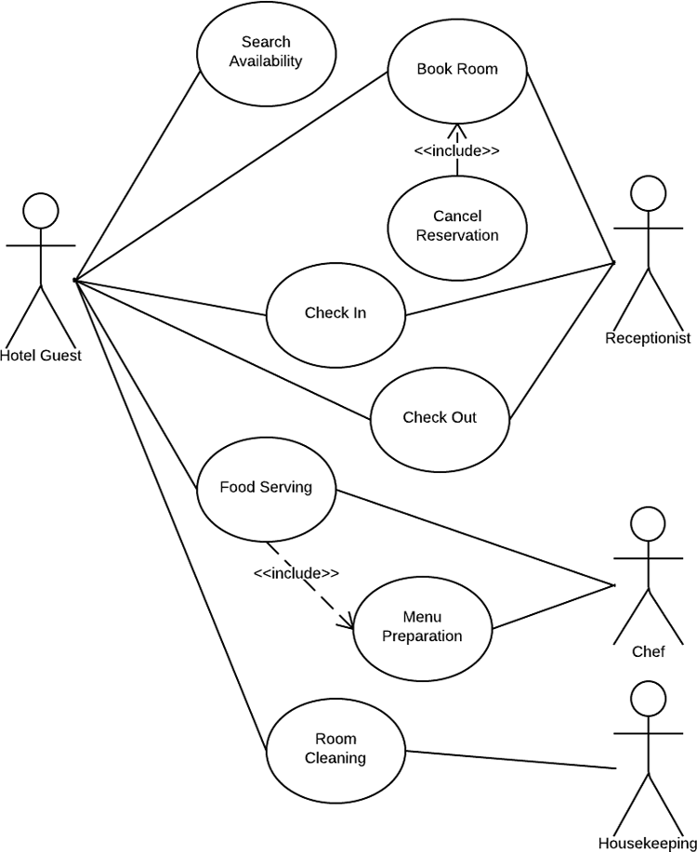

**2.ACTIVITY DIAGRAM**

Explanation:

* **Customer Check-In Process:**
  + **Start:** The process begins when a customer arrives at the hotel.
  + **Check Room Availability:** The system checks for available rooms.
  + **Select Room:** The customer selects a room based on availability.
  + **Provide Details:** The customer provides personal details for check-in.
  + **Assign Room:** The system assigns the selected room to the customer.
  + **Generate Invoice:** An invoice for the stay is generated.
  + **End:** The process ends after successful check-in.
* **Customer Check-Out Process:**
  + **Start:** Triggered when a customer decides to check out.
  + **Calculate Bill:** The system calculates the final bill for the stay.
  + **Payment:** The customer makes the payment for the stay.
  + **Check-Out:** The system updates the room status to 'available' and marks the customer as checked out.
  + **End:** The process ends after successful check-out.
* **Room Service Request Process:**
  + **Start:** Initiated when a customer requests room service.
  + **Receive Request:** The system receives the room service request.
  + **Check Availability:** Checks if the requested service is available.
  + **Service Delivery:** If available, the requested service is delivered to the customer's room.
  + **End:** The process ends after service delivery.
* **Admin Functions:**
  + **Start:** Initiated when an administrative function is required.
  + **Login:** The admin logs into the system.
  + **Access System:** After successful login, the admin gains access to system functionalities.
  + **Perform Admin Tasks:** Various administrative tasks can be performed, such as managing rooms, staff, inventory, etc.
  + **Logout:** The admin logs out of the system.
  + **End:** The process ends after successful logout.

This diagram represents the flow of activities within a hotel management system. It covers key processes like customer check-in, check-out, room service requests, and administrative functions.

**ACTIVITY DIAGRAM**

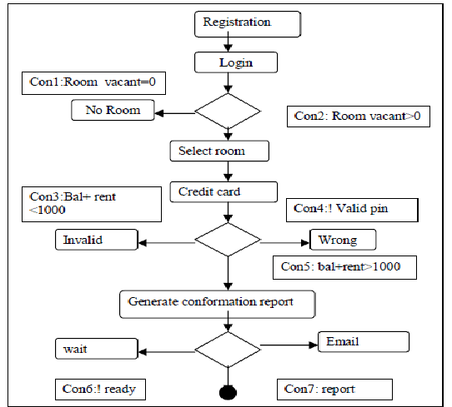

**3.SEQUENCE DIAGRAM**

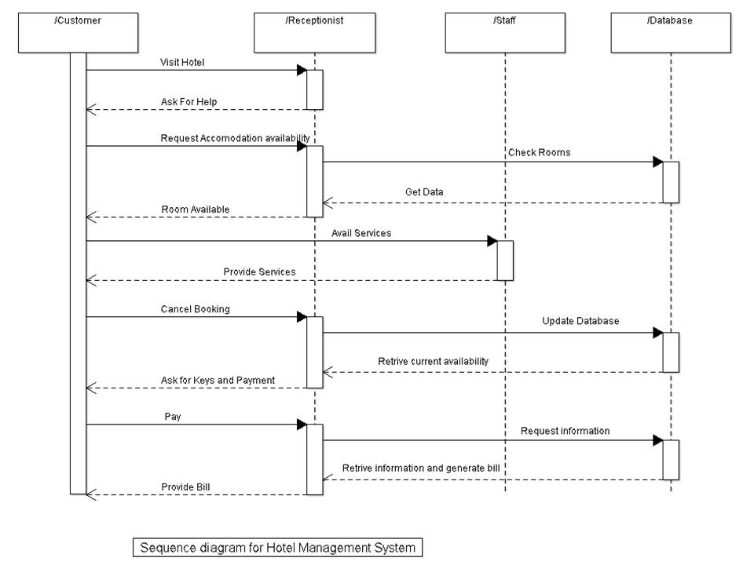

**4.ER DIAGRAM**

Designing an Entity-Relationship (ER) diagram for a hotel management system involves identifying entities, their attributes, and the relationships between them. Here's a simplified representation:

Entities:

* **Guest**: Attributes might include GuestID, Name, Address, Email, Phone.
* **Reservation**: Attributes could be ReservationID, Check-in Date, Check-out Date, Number of Guests.
* **Room**: Attributes might include RoomID, Room Type, Price, Availability.
* **Employee**: Attributes could be EmployeeID, Name, Position, Shift.

Relationships:

* **Guest makes Reservation**: A Guest can make one or multiple reservations.
  + *Relationship type*: One-to-Many from Guest to Reservation.
* **Reservation includes Room**: A Reservation can include one or more rooms.
  + *Relationship type*: Many-to-Many between Reservation and Room (via a junction table).
* **Employee manages Reservation**: An Employee manages one or more reservations.
  + *Relationship type*: One-to-Many from Employee to Reservation.

This is a basic structure. Depending on the complexity of the hotel management system and additional functionalities, there might be more entities (e.g., Payment, Services), attributes, or relationships (e.g., Employee supervises Employee) to include in the ER diagram.

The ER diagram would depict these entities as boxes, their attributes as ovals within the boxes, and lines between boxes to represent relationships, indicating cardinality and optionality (e.g., one-to-many, many-to-many).

**4.ER DIAGRAM**

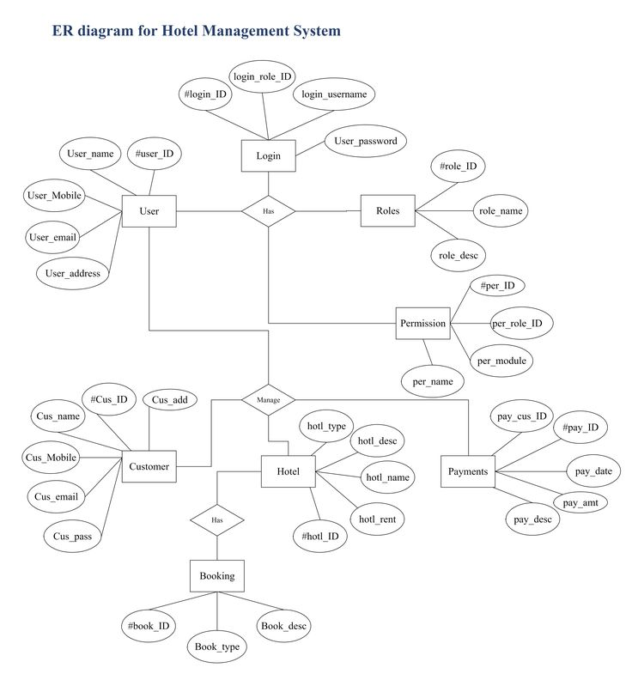

***Conclusion***

Our project is only a humble venture to satisfy the needs to manage their project work . Several User friendly coding have also adopted .

At the end it is concluded that we have made effort on following points :

* A description of the background and context of the project and its relation to work already done in the area.
* Made statement of the aims and objectives of the project .
* The description of purpose , scope and applicability .
* We describe the requirement specifications of the system and the actions that can be done on these things .
* We included features and operations in detail ,including screen layout . We designed user interface and security issues related to system .